Yizhan Ao
STAT430
Project2
April. 26, 2022
- Do a write up on the regression of your two quantitative variables of interest.
  - Anova results from the PROC REG and what it means (p-value and significance)
    - Our p value is P-value < 0.001. and we have set the confident interval to 95%, which means the differences between the variances of the means are staIsIcally significant. In other words, this proof the raIonality of using the linear regression.
  - The r-squared value and what it means. ( 10points)
    - Our R-squared value is 0.0681
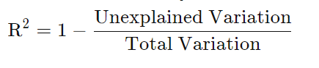
We have the R^2 to be the value of variance explained by the model divided by the total variance. The r^2 value is low. But we could have guessed that by looking at the scatterplot. It seemed linear for smaller values of hours. Our R squared value is not very good is because of several outliers from CGPA of 2.7-3.3 from the probability plot listed.
  - Regression results and what it means (p-values on variables, significance, residuals)
    - Regression equation:
      - CGPA = -0.04200* hours spent in library + 3.76723
        - P value for the independent variable
      - The p-value for the independent variable(s) (10points)
        - We have the p value to be very small for the intercept so intercept is very significant and the value for each major and other independent variables are shown below so we could see the year is taking a very important place as well.

      - Explain what the p-values mean (10points)
        - The P-values of independent values Average Hour/ Sp, What Major ? ART/ARCHITEKT/DESIGN, What Major ? BUSINESS and What Major ? OTHERS are less than 0.05. However, the others are greater than 0.05. Since our CI is 95%, only the values with P-value <0.05 are significant to this regression model. Therefore the only significant variables are architectural and business to my model
      - The residual analysis, look at the normal probability plot and analyze (10points) and the residuals by regression for dependent variable (10points)
        - We are having a roughly symmetric bell shaped curve in our normal distribution. We could infer that the distribution of residuals is followed by a normal distribution
        - Similar result from the regression plot. Most of data points are predicted probably. Therefore, this is model performs pretty well from the residuals perspective. There are very few outliers on the plot
        - From the probability plot for CGPA we have the plot to be basically linear only a few outliers exist in the end points

      - Make sure all assumptions are met. Explain what this does to your results. (10points.)
        - The model fit our data well but the performance of independent variables are not well. Many independent variables are having p values grater than 0.05 which is caused by the data points distributed. The residual distribution is roughly normal, and the input of the R squared value to be very low. We have the data to be well performed by the MSE to be very low which means the error of the model is low. Therefore the accuracy is high

CODE:
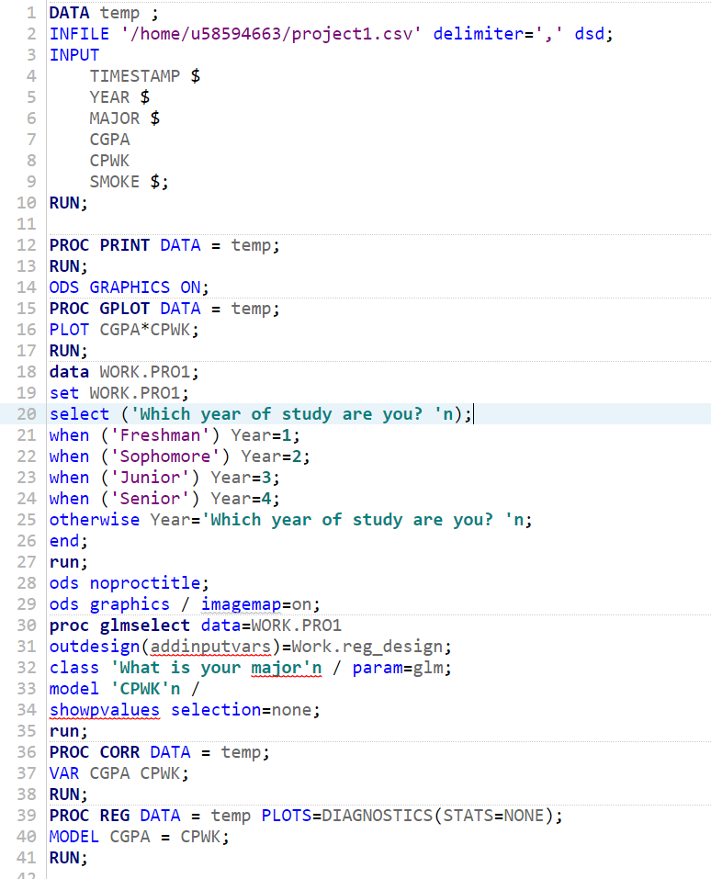

Obs | TIMESTAMP | YEAR | MAJOR | CGPA | CPWK | SMOKE
1 | 2/16/202 | Sophomor | CS | 2.70 | 3.0 | Yes
2 | 2/16/202 | Sophomor | MATH | 2.90 | 3.0 | Yes
3 | 2/16/202 | Senior | CS | 3.86 | 2.0 | No
4 | 2/16/202 | Senior | MATH | 3.90 | 4.0 | No
5 | 2/16/202 | Sophomor | STAT | 3.40 | 3.0 | Yes
6 | 2/16/202 | Senior | ECON | 3.56 | 3.0 | Yes
7 | 2/16/202 | Senior | CS | 3.97 | 8.0 | Yes
8 | 2/16/202 | Senior | ECON | 3.78 | 1.0 | Yes
9 | 2/16/202 | Senior | Media de | 3.70 | 2.0 | No
10 | 2/16/202 | Senior | BIO | 2.80 | 12.0 | Yes
11 | 2/16/202 | Freshman | FINA | 3.50 | 7.0 | No
12 | 2/16/202 | Senior | INFOSCI | 3.95 | 5.0 | Yes
13 | 2/16/202 | Freshman | ECON | 4.00 | 4.0 | No
14 | 2/16/202 | Freshman | CS | 3.67 | 3.0 | No
15 | 2/16/202 | Senior | PHS | 3.70 | 2.0 | Yes
16 | 2/16/202 | Junior | CS | 3.87 | 3.0 | No
17 | 2/16/202 | Freshman | FINA | 3.96 | 2.5 | No
18 | 2/16/202 | Senior | CS/MATH | 3.30 | 3.0 | No
19 | 2/16/202 | Junior | CS | 3.20 | 6.0 | Yes
20 | 2/16/202 | Junior | ECON | 3.00 | 6.0 | No
21 | 2/16/202 | Senior | CS | 3.30 | 4.0 | No
22 | 2/16/202 | Junior | CS | 3.85 | 3.5 | No
23 | 2/16/202 | Senior | BIO | 3.70 | 1.2 | Yes
24 | 2/16/202 | Junior | IS & OMB | 3.60 | 7.0 | No
25 | 2/16/202 | Junior | ECON | 3.97 | 4.0 | No
26 | 2/16/202 | Senior | SUPPLYC | 3.80 | 2.0 | Yes
27 | 2/16/202 | Junior | ARCH | 3.50 | 2.0 | No
28 | 2/16/202 | Junior | CS | 3.85 | 6.0 | No
29 | 2/27/202 | Senior | ECON | 3.50 | 3.0 | No
30 | 2/28/202 | Sophomor | CS | 3.40 | 3.0 | Yes
31 | 2/28/202 | Senior | ECON | 3.76 | 4.0 | No
32 | 2/28/202 | Sophomor | CS | 4.00 | 5.0 | No
33 | 2/28/202 | Senior | CS | 3.90 | 3.0 | No

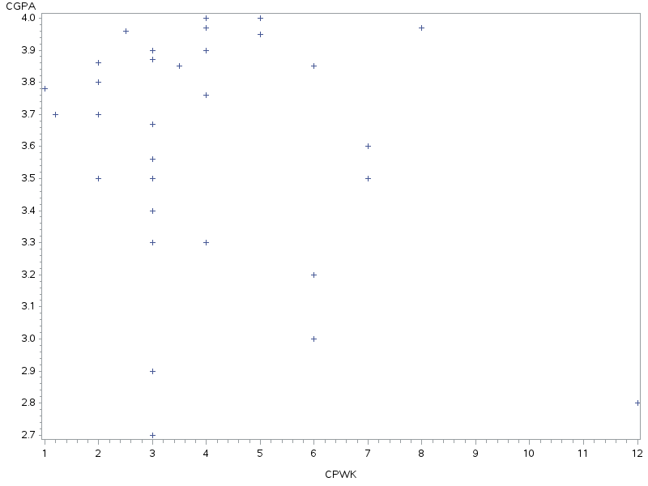

2 Variables: | CGPA CPWK

Simple Statistics
Variable | N | Mean | Std Dev | Sum | Minimum | Maximum
CGPA | 33 | 3.60152 | 0.36124 | 118.85000 | 2.70000 | 4.00000
CPWK | 33 | 3.94545 | 2.24473 | 130.20000 | 1.00000 | 12.00000

Pearson Correlation Coefficients, N = 33
Prob > |r| under H0: Rho=0
 | CGPA | CPWK
CGPA | 1.00000 | -0.26099  0.1424
CPWK | -0.26099  0.1424 | 1.00000

Model: MODEL1
Dependent Variable: CGPA
Number of Observations Read | 33
Number of Observations Used | 33

Analysis of Variance
Source | DF | Sum of  Squares | Mean  Square | F Value | Pr > F
Model | 1 | 0.28444 | 0.28444 | 2.27 | <.0001
Error | 31 | 3.89138 | 0.12553
Corrected Total | 32 | 4.17582

Root MSE | 0.35430 | R-Square | 0.0681
Dependent Mean | 3.60152 | Adj R-Sq | 0.0381
Coeff Var | 9.83753

Parameter Estimates
Variable | DF | Parameter  Estimate | Standard  Error | t Value | Pr > |t|
Intercept | 1 | 3.76723 | 0.12619 | 29.85 | <.0001
CPWK | 1 | -0.04200 | 0.02790 | -1.51 | <.0001

Model: MODEL1
Dependent Variable: CGPA
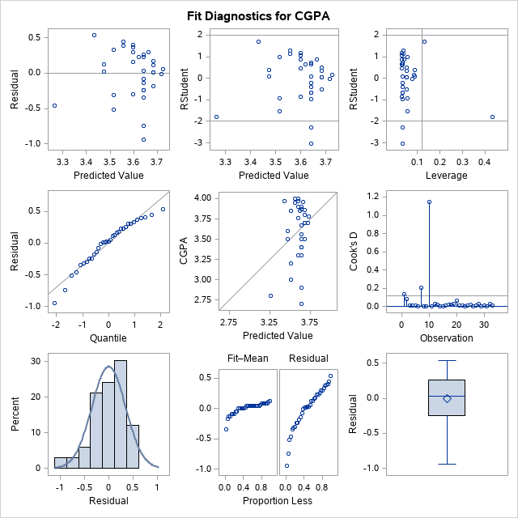
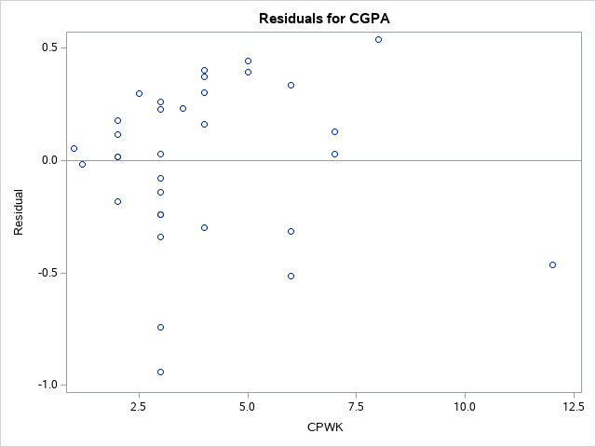
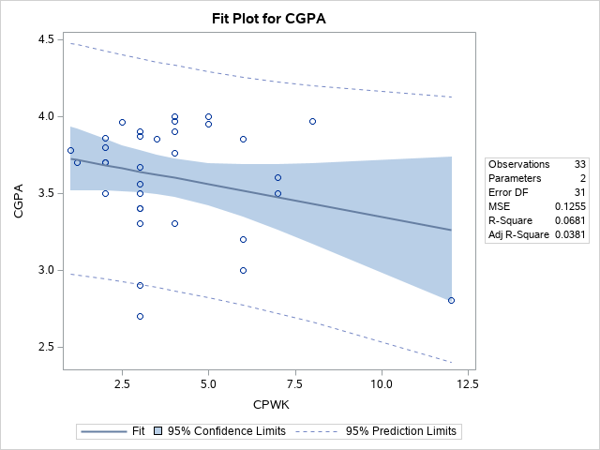

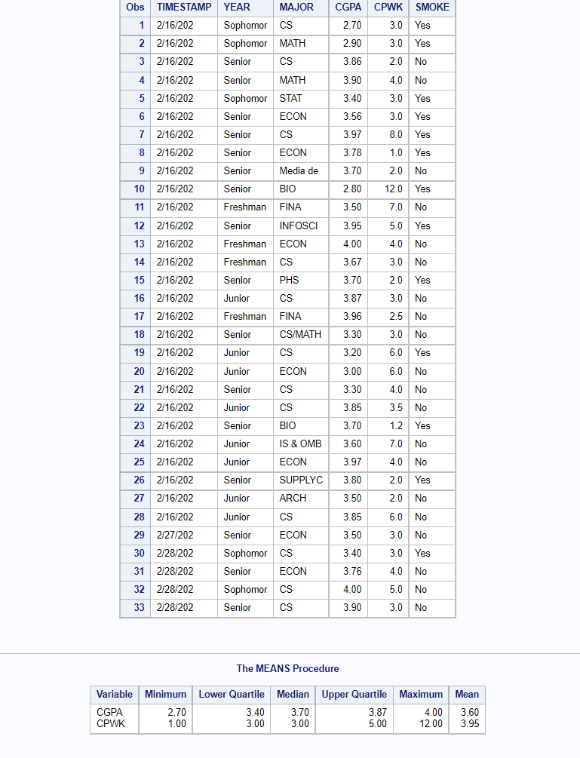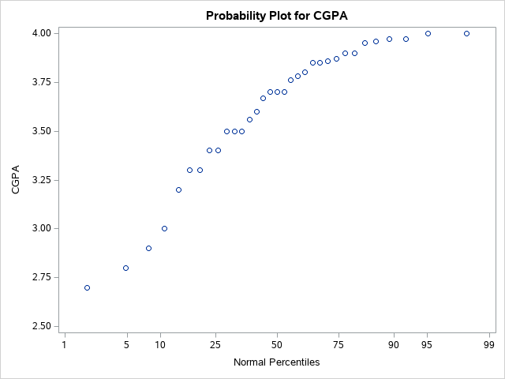

PROC CORR 